**DATA STRUCTURES AND ALGORITHM PROJECT**

**SLO MAPPING**

18BCE2354- PRAJEETH KUMAR M.J

18BCE2356- SUMANTH KRISHNA K

in partial fulfilment for the award of the degree of

**B. Tech**

In

**School of Computer Science and Engineering**

SUBMITTED TO :

DR.MURALI.S

ASSOCIATE PROFESSOR



Vellore-632014, Tamil Nadu, India

**School of Computer Science and Engineering**

**March, 2018**

**1.INTRODUCTION**

Students Learning Outcome (SLO) is the process of collecting information that will tell the faculty whether the assessments they offer are having thedesired impact on those who take part in them.

One of the great advantages of Students Learning Outcome (SLO) is that when done in a systematicway, it has benefits for people throughout the institution, from our students to the facultyto the administration.

Co-ordinators in a university store all the information of the students and their academic performances. If a student has opted for “n” subjects the details of their performances and teacher information is displayed on the screen. If a teacher has chosen to upload the marks of the student, they will be provided with mark distribution of each and every question. The teacher will be asked to enter the learning outcomes of the question selected. So we prepare a graph of the frequency of the outcomes of all questions in the exam. The Teacher can also add remarks to the question if necessary. We will also calculate the class average using the marks of all the students present under the specific teacher.C++ is used for the creation of classes and pointers. We can create the classes and call it wherever required.

Finally we have designed a code to display a table to make in in an organised manner.

2. Overview

**MODULES IMPLEMENTED**

1. Authentication Module
2. Updating Blueprint
3. Data Entry of Marks – [Student wise]
4. Tabular Representation of Marks
5. SLO Representation of Marks

Authentication

A default username and password of the system is “admin”.

UpdatingBlueprint

Number of question along with their weightage and their respective SLO’s are updated. And number of students are also specified.

Data Entry of Marks – [Student wise]

The name and register number of the students are entered, followed by their marks for the respective questions.

Tabular Representation of Marks

Entered marks are displayed in a tabular format along with the total (question wise and student wise)

SLO Representation of Marks

Questions with the same SLO are grouped together to find SLO total, average and attainment %. And the result is displayed in a tabular format.

Module 1:

The first module involves the creation of login page separately for coordinator and the teacher.

Module 2:

After creation of login page, the coordinator will sign up using the given username and password. The coordinator will have the access to assign the SLO’s for the questions. He will be given the access to assign the number of sub divisions in each question. For each sub division he can assign the weightage of marks and the maximum limit to each of them.

Module 3:

The teacher after login will have the access to register student’s names and registration number. For each student he can assign the marks designated by the coordinator. All the student’s names will be recorded and will be assigned by marks in respective examinations.

Module 4:

A table is created to show the student’s details like name and registration number along with the marks and the respective SLOs.

Module 5:

After the construction of table, the frequency of the SLOs will be counted and the result will take each of the subdivisions into consideration. SLO of each subdivision will be counted.

Module 6:

Average of the questions containing a specific SLO of every student will be recorded. i.e for each SLO there is a count of number of marks scored by each student in the particular examinations.

RESULT:

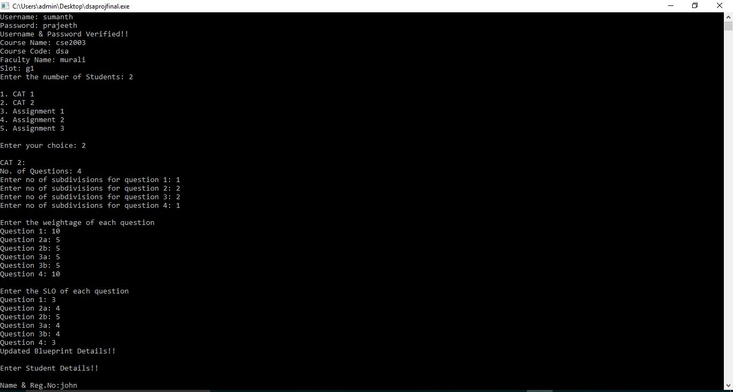

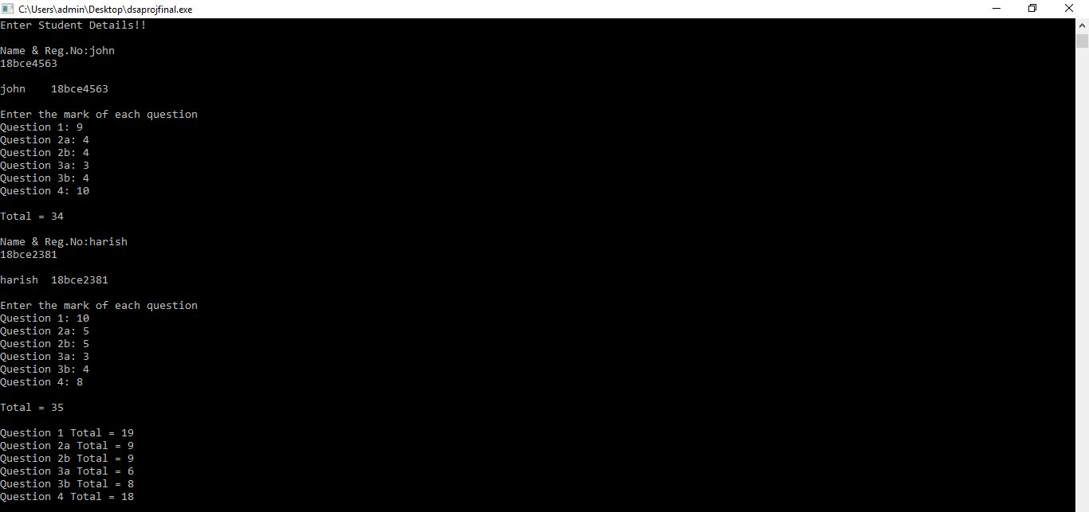

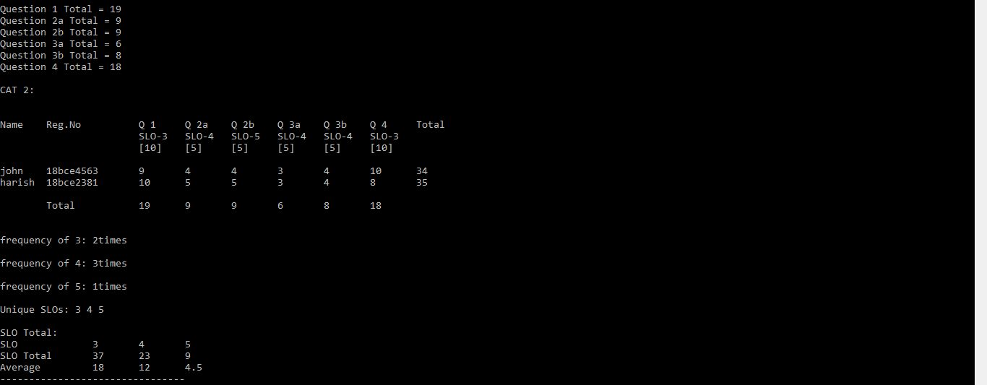

Using the above program we are able to help the teachers and coordinators to add marks and SLOs of the students respectively in a neat manner.

**CONCLUSION:**

Form this project we learnt how to use classes and inheritance. We used the concept of multidimensional arrays to store information of different student’s marks and the SLOs frequency. This SLO mapping system is very effective towards providing a systematic output of the question paper. It makes sure, the correct SLOs are provided in each examination. The work of the coordinator will become easyprior to the paper setting. This ensures the division of marks is equally set for all the lessons or according to the coordinator’s interest. It is a teacher friendly algorithm where the teacher can easily get the table of SLOs and average of the student’s performances in the examination. The frequencies of the SLOs are also calculated in this algorithm to get an insight of the examination.

REFERENCE:

Referred these SLO templates.

